әл-Фараби атындағы қазақ ұлттық университеті



Зертханалық жұмыс № 7

**Пән: Сетевые технологии**

**Тақырыбы: Wi-Fi**

Тексерген: Маликова Ф. У.

Орындаған: Якуфуцзян Азати

Тобы: ВТиПО

## Wi-Fi configuratin on Cisco Packet Trace

1. We need one Access Point RT wireless router, one router, one 3560 24ps Multilayer Switcher, one Linksys Wireless Router, and 4 PCs as follows:

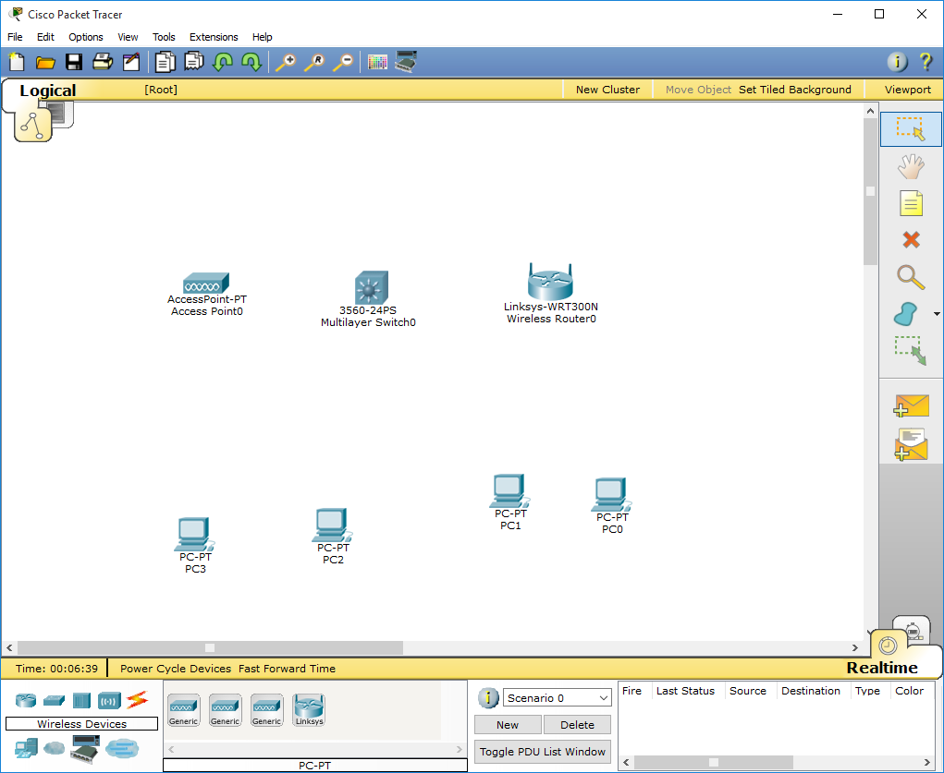

1. The topology of whole wireless System looks like :

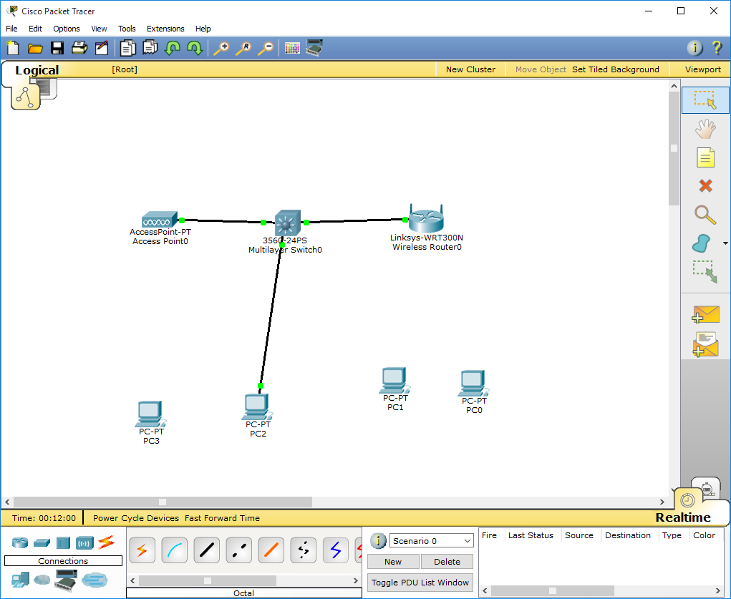

1. We use 3560 switcher as the Core switcher and configure as follows:

Switch>enable

Switch#configure terminal

Enter configuration commands, one per line. End with CNTL/Z.

Switch(config)#

Switch(config)#int vlan 1

Switch(config-if)#ip add 192.168.0.1 255.255.255.0

Switch(config-if)#no shut

Switch(config-if)#

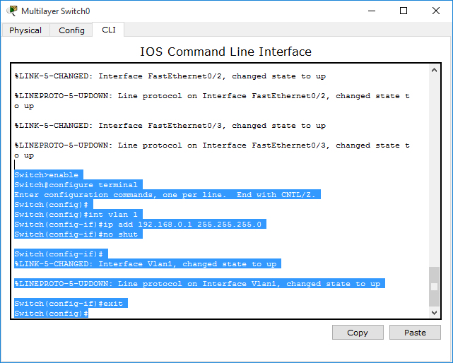

1. Configure DHCP on VLAN 1 so that PC2 can auto-get ip address:

Switch(config-if)#

%LINK-5-CHANGED: Interface Vlan1, changed state to up

%LINEPROTO-5-UPDOWN: Line protocol on Interface Vlan1, changed state to up

Switch(config-if)#exit

Switch(config)#ip dhcp pool dhcp

Switch(dhcp-config)#network 192.168.0.0 255.255.255.0

Switch(dhcp-config)#default-router 192.168.0.1

Switch(dhcp-config)#dns-server 61.139.2.69

Switch(dhcp-config)#ip dhcp excluded-address 192.168.0.1 192.168.0.1

Switch(config)#ip dhcp excluded-address 192.168.0.254 192.168.0.254

Switch(config)#

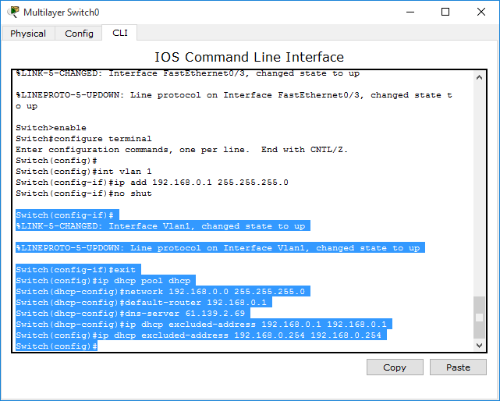

1. Then, we configure VLAN2 as wireless vlan ,as follows :

Switch(config)#vlan 2

Switch(config-vlan)#exit

Switch(config)#int fa0/1

Switch(config-if)#switchport mode acc

Switch(config-if)#sw acc vlan 2

Switch(config-if)#exit

Switch(config)#int vlan 2

Switch(config-if)#

%LINK-5-CHANGED: Interface Vlan2, changed state to up

%LINEPROTO-5-UPDOWN: Line protocol on Interface Vlan2, changed state to up

Switch(config-if)#ip add 192.168.1.1 255.255.255.0

Switch(config-if)#no shut

Switch(config-if)#exit

Switch(config)#

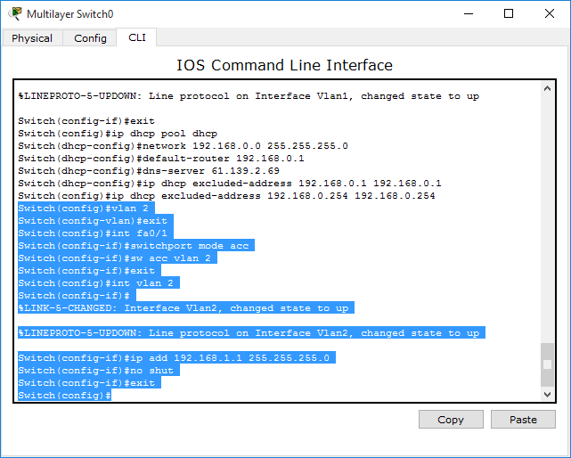

1. Configure VLAN2 as follows:

Switch#config

Configuring from terminal, memory, or network [terminal]?

Enter configuration commands, one per line. End with CNTL/Z.

Switch(config)#ip dhcp pool vlan2

Switch(dhcp-config)#network 192.168.1.0 255.255.255.0

Switch(dhcp-config)#default-router 192.168.1.1

Switch(dhcp-config)#dns-server 192.168.1.1

Switch(dhcp-config)#exit

Switch(config)#ip dhcp excluded-address 192.168.1.1 192.168.1.1

Switch(config)#ip dhcp excluded-address 192.168.1.254 192.168.1.254

Switch(config)#

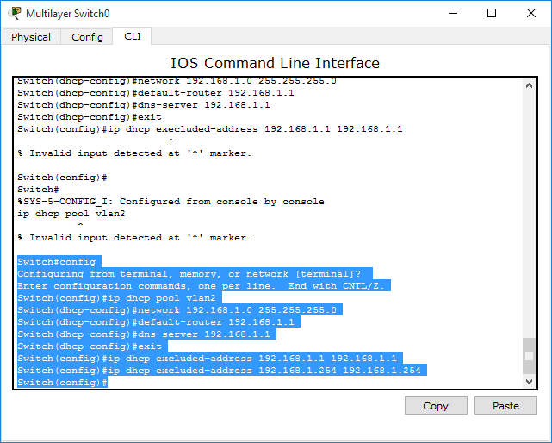

1. Configure VLAN3 for a wireless AP

Switch(config)#vlan 3

Switch(config-vlan)#exit

Switch(config)#int fa0/2

Switch(config-if)#sw mo acc

Switch(config-if)#sw acc vlan 3

Switch(config-if)#exit

Switch(config)#int vlan 3

Switch(config-if)#

%LINK-5-CHANGED: Interface Vlan3, changed state to up

%LINEPROTO-5-UPDOWN: Line protocol on Interface Vlan3, changed state to up

Switch(config-if)#ip add 192.168.2.1 255.255.255.0

Switch(config-if)#no shut

Switch(config-if)#exit

Switch(config)#ip dhcp pool vlan3

Switch(dhcp-config)#network 192.168.2.0 255.255.255.0

Switch(dhcp-config)#default-router 192.168.2.1

Switch(dhcp-config)#dns-server 192.168.2.1

Switch(dhcp-config)#exit

Switch(config)#ip dhcp ex

% Incomplete command.

Switch(config)#ip dhcp excluded-address 192.168.2.1 192.168.2.1

Switch(config)#exit

Switch#

%SYS-5-CONFIG_I: Configured from console by console

Switch#

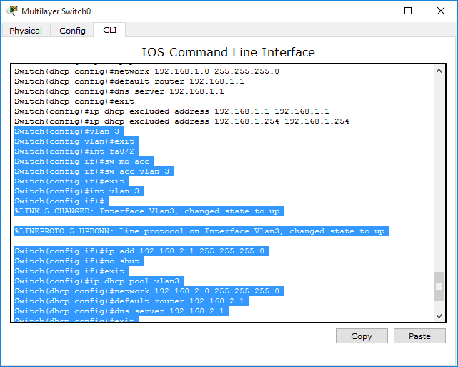

1. Applied VLAN configuration and topology as follows :

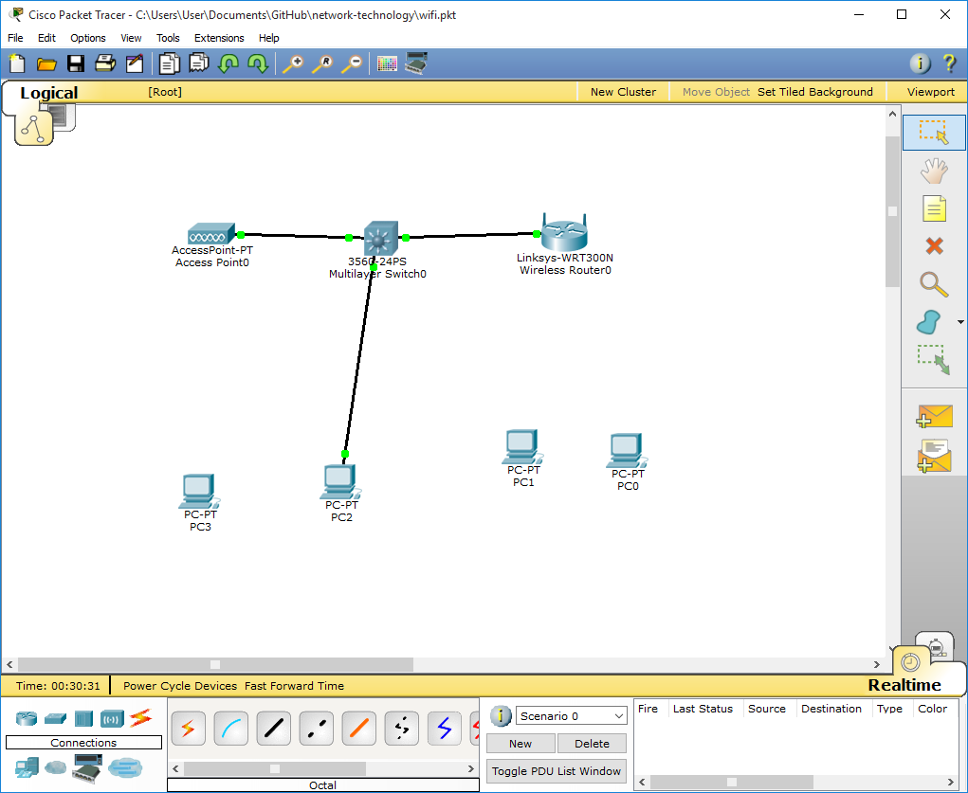

1. We have to Assure that PC2 got ip address automatically

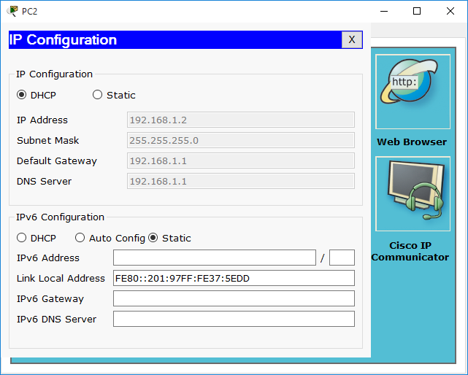

PC2:

IP address :192.168.1.2

Subnet mask :255.255.255.0

Gateway: 192.168.1.1

DNS Server 192.168.1.1

1. Now, you see that the denied will not be able to send the data while those who we permit can send packet.

